# **Red Hat JBoss BRMS**

# **Weight Watcher Demo**

**Use case: stateless CEP decision service**

Stefano Picozzi

ANZ OpenShift SME

Sydney, Australia

spicozzi@redhat.com

**Table of Contents**

1 Introduction 3

2 Setup 3

2.1 Project Download 3

2.2 Software Downloads 4

3 Deployment 5

3.1 Installation Script 5

4 Configuration 6

4.1 Register Decision Server 7

4.2 Build/Deploy the Project 8

4.3 Create/Start a Container 8

5 Running the Demo 9

5.1 Health Check 9

5.2 Basic Decision Server 9

5.3 Advanced Workbench 10

5.4 High Availability 11

6 Containers 13

6.1 Container Deployment 13

# Introduction

Interested in a demo that showcases the JBoss BRMS 6.1 Real Time Decision Server? Then look here. The application is a stateless Decision Server with complex event processing (CEP) support based on a pseudo clock.

An example use case demonstrated includes a (REST) client sending a time series of *facts* in the form of weight observations to the Decision Server. The Decision Server then reasons over the inputs to derive CEP insights such as average weight, least weight and weight change of a rolling time window. These insights are returned to the calling client as *facts*.

This is a facts-in-facts-out (FIFO) pattern using a standardized fact interface representation. This technique makes it easier for a simple thin client application such as SoapUI to send request/response payloads to the Decision Server without knowledge of the underlying rules data model.

<http://blog.emergitect.com/2014/12/08/really-simple-rules-service/>

# Setup

## Project Download

You first need to get the project by cloning it from the central location:

|  |
| --- |
| $ git clone git://github.com/StefanoPicozzi/weightwatcher.git |

Once downloaded, you will have the following folder structure:

* \weightwatcher
  + \installs – Initially empty, but will contain the EAP, BRMS platform downloads.
  + \support– Artefacts to assist in a traditional workstation installation
  + \container – Artefacts to assist in nginx container installation
  + \docs – Contains quickstart guide you are reading and architectural overview slides.
  + \test – SoapUI project files with configuration, samples and test invocations
  + \projects – source code including data model, rules and project settings

## Software Downloads

Some test cases and configuration steps make use of the SoapUI functional testing tool. If you do not have it, download and install SoapUI from <http://www.soapui.org/> .

Download JBoss BRMS from the Red Hat Customer Portal ([https://access.redhat.com](https://access.redhat.com/)).

1. Under JBoss Enterprise Platforms, select the BRMS product.
2. Select version *6.1.0* in the *Version* field.
3. Download Red Hat JBoss BMRS 6.1.0 installer

Then copy jboss-brms-6.1.0.GA-installer.jar, to the projects *installs* folder. Ensure that this file is executable by running:

|  |
| --- |
| $ chmod +x <path-to-project>/installs/jboss-brms-6.1.0.GA-installer.jar |

Download JBoss EAP 6.4:

1. Under JBoss Enterprise Platforms, select the EAP product.
2. Select version *6.4* in the *Version* field.
3. Download Red Hat JBoss eap 6.4 installer

Now copy jboss-EAP-6.4.0-installer.jar, to the projects *installs* folder. Ensure that this file is executable by running:

|  |
| --- |
| $ chmod +x <path-to-project>/installs/jboss-EAP-6.4.0.-installer.jar |

# Deployment

Various deployments models are supported as described below. In all cases, once the application is started, you can access the browser based workbench console via:

http://localhost:8080/business-central (u:erics / p:jbossbrms1! )

## Installation Script

This step will deploy the application to \target directory. To do this, run the *init.sh* script and then configure the application as described in the next section.

|  |
| --- |
| $ cd <path-to-project>  $ ./init.sh |

When the script completes you will have a new folder named *jboss-eap-6.4*, in the \target folder. The folder is a ready to run EAP 6 server with JBoss BRMS. Launch an instance of your new BRMS application and then complete the configuration steps detailed in the next chapter.

|  |
| --- |
| $ cd <path-to-project>  $ ./target/jboss-eap-6.4.0/bin/standalone.sh |

# Configuration

Configuration consists of 1) building/deploying the project jar file; 2) registering a new Decision Server and 3) starting a Container for our new server. All steps aside from server registration can be completed using an API. The intention is to fully automate the procedure via a script/maven once APIs are located to replace the manual Workbench. Configuration is summarised as follows:

1. (Workbench) Login to the workbench and then register a new Decision Server
2. (SoapUI) Build/deploy the project with the supplied REST/POST command
3. (SoapUI) Create/start a container for our new server using the supplied REST/PUT command

## Register Decision Server

Workbench related steps require you login first ( u:erics/p:jbossbrms1! )

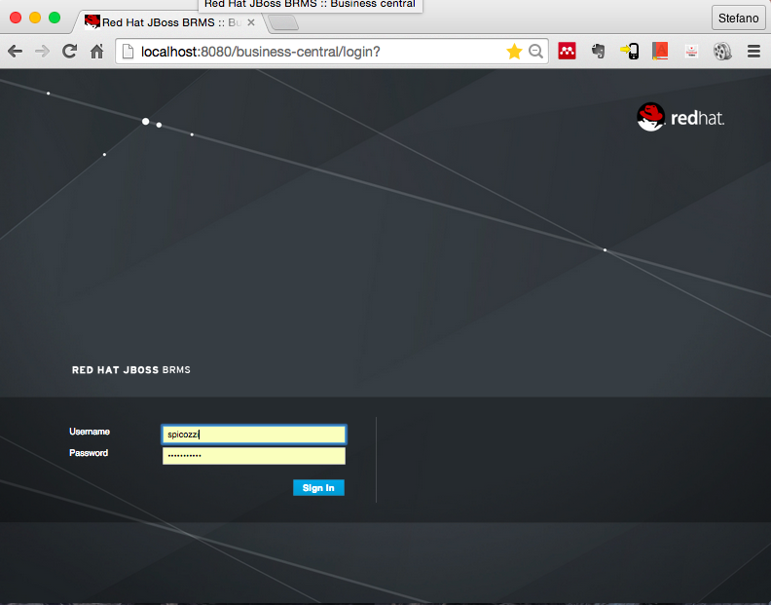

The register new decision server step is accessible from the Deploy menu. Complete the registration as follows:

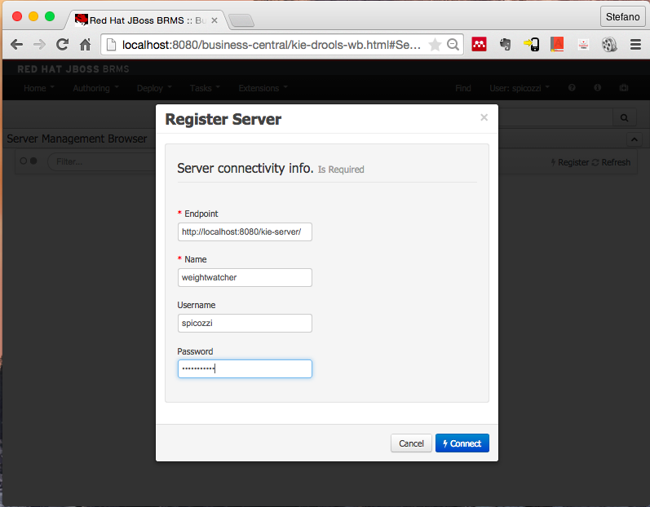

## Build/Deploy the Project

Launch the SoapUI tools and then import the project with a name that includes the label "Project Management". Locate the "Maven Build" resource and then execute the REST/POST Build&Deploy request.

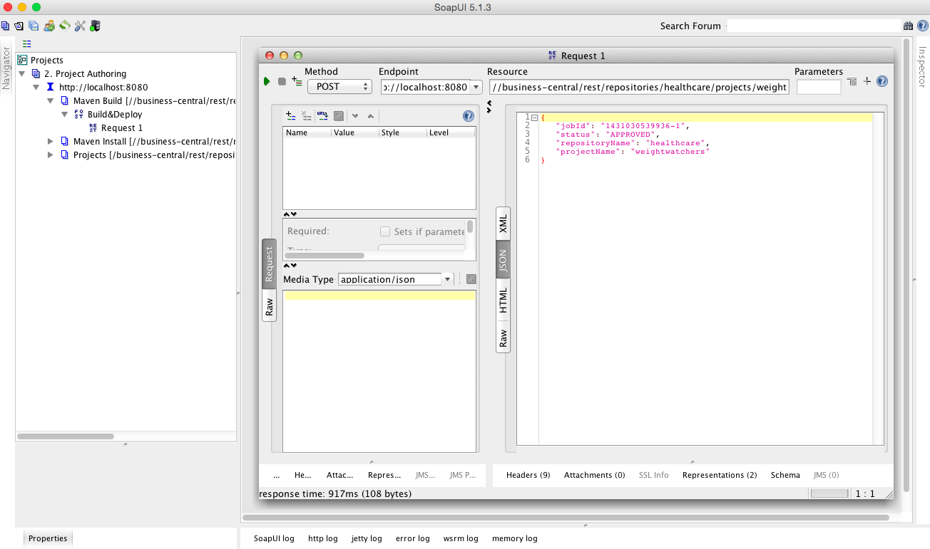

## Create/Start a Container

Launch the SoapUI tools and then import the project with a name that includes the label "KIE Server". Locate the "Container" resource and then execute the REST/PUT Create Container request.

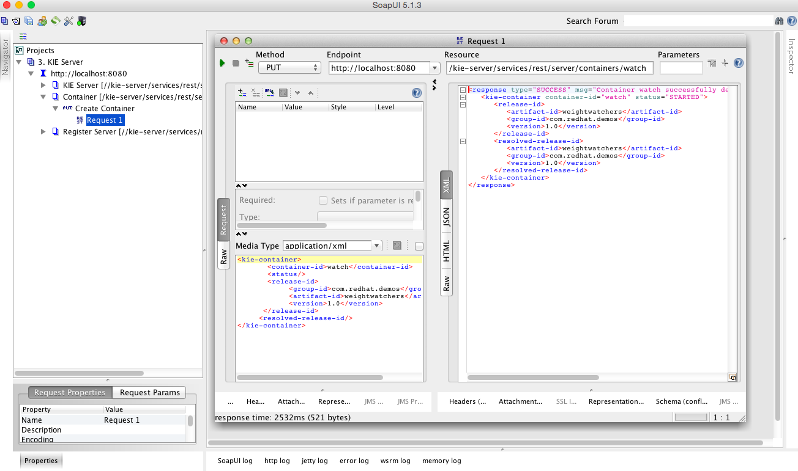

# Running the Demo

## Health Check

Before attempting any of the following demonstrations, ensure that the Decision Server's Container is ready to accept requests. Check this by repeating the "4.3 Create Container" step described previously. If this invocation fails, then check the earlier steps to ensure your application is correctly installed and configured.

## Basic Decision Server

This demo shows a stateless request/response interaction with the Real Time Decision Server. Launch the SoapUI tools and then import the project with a name that includes the label "Business APs". The 3 supplied resources and REST POST requests are samples representing the following.

"Facts" shows a simple request in which a request payload of facts are *inserted* into the Decision Server knowledge and then a *query* is issued to verify this action has been successful.

The "Weight Watch" sample shows an invocation in which a set of facts containing weight measurements is sent to the Decision Server. CEP rules are then applied to derive insights as per the response payload. The request consists of facts representing Participant, Goal and Observation data records. The Participant records capture details of the user, Goal captures the Participant's target weight objectives and Observation records a time series of weight measurements. The response payload then returns a set of facts reporting minimum, maximum and weight change statistics over a sliding time window.

The "Goal Attainment" sample demonstrates a use case in which the Participant has elected to enter into a period of intermittent fasting, known as the Fast Diet http://thefastdiet.co.uk/. The GAS fact represents the Participant's number of fasting day goals over the week, described in ranges of worst through to best outcomes, refer http://en.wikipedia.org/wiki/Goal_Attainment_Scaling for details on the method. The Observation records then report back actual days of fasting in the previous weeks. The Decision Server then responds back with performance against goals. The GAS fact table is a candidate for remodelling using, e.g. a Guided Decision Tables.

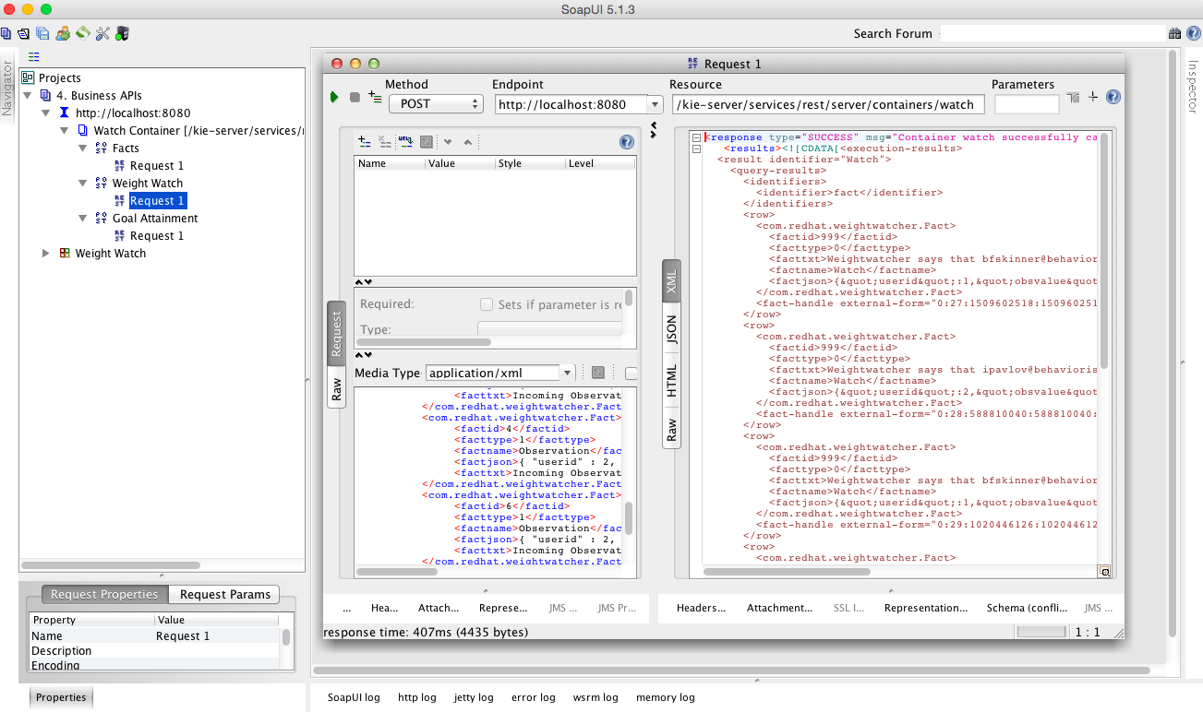

## Advanced Workbench

You can also experiment with changing and creating rules and observing their impact. To do this, try the following from within the JBoss BRMS workbench:

* Select the Deploy menu and delete the watch container created previously
* Visit the weightwatcher project and edit the DRL named GASScore under the weightwatcher project
* Change the rule “ruleExpectedCount” so that it only counts when the Participant meets exactly his expected result (obsvalue == 0) and change the message accordingly by removing the “or better” text
* Rebuild the workbench project jar file
* Select the Deploy option again and recreate the watch container, you can also do this using the REST API instruction as in section 2.1
* Start the watch container
* Now return to the SoapUI client and invoke the GAS Watch API and confirm the changed rule behavior

The modified rule will look like:

|  |
| --- |
| rule "ruleExpectedCount"  salience -100  no-loop true  when  $participant : Participant( )  $gas : GAS( userid == $participant.userid )  $obscounttotal : Number( intValue > 0) from accumulate(  Observation( $obscount : obsvalue == 0, $participant.userid == userid, obsname == $gas.goalname ) over window:time( 60d ),  count( $obscount ) )  then  String rulename= new String( drools.getRule().getName( ) );  Integer userid = $participant.getUserid( );  String factname = new String( "Watch" );  String username = new String( $participant.getUsername( ) );  String facttxt = new String( "Weightwatcher says that for " + $gas.getGoalname( ) + ", " + username + " attained expected outcome " +  $obscounttotal + " times over the past 60 days" );  // Rest removed |

## High Availability

A high-availability and load balancing demonstration is also available. This will work on a single host if required. To do this, build an nginx container to act as a load balancing reverse proxy and then launch it with the docker run command. If your weightwatcher application(s) are deployed to localhost on ports 8080 and/or 8081 then simply pull down the prebuilt nginx container:

|  |
| --- |
| $ docker pull spicozzi/nginx |

If not using localhost, then you need to build your own nginx container. Before you initiate the nginx build command check the container/nginx/default file and edit the upstream weightwatcher target to reflect the hostname of your workstation as per the fragment shown below.

upstream weightwatcher {

server localhost:8080;

server localhost:8081;

}

|  |
| --- |
| $ cd <path-to-project>  $ cd container/nginx  $ vi nginix/default # Change hostnames as appropriate  $ docker build -t spicozzi/nginx .  $ docker run -d -p 80:80 --name nginx spicozzi/nginx \  nginx -g "daemon off;" |

The nginx instance will proxy URIs with /kie-server/ to an upstream pair of docker BRMS server containers listening on 8080 and 8081 respectively. Note that this will require a workstation with more than 8 GBytes RAM. These instances could be traditional or container based deployments. For container based images, you would launch a pair of servers like below. Container deployments are described in section 6.

|  |
| --- |
| $ cd <path-to-project>ß  $ docker run -d -p 8080:8080 -p 9090:9090 --name weightwatcher1 \  spicozzi/weightwatcher  $ docker run -d -p 8081:8080 -p 9091:9090 --name weightwatcher2 \  spicozzi/weightwatcher \ |

Other useful docker commands include, using weightwatcher1 named instance as an example:

|  |
| --- |
| $ docker ps -l  $ docker rm -f weightwatcher1  $ docker logs -f weightwatcher1 |

Once the docker containers are tunning, you can then experiment with unit and load testing as per tests located in the SoapUI projects as per screen shot below. To do this import the weightwatcher-QoS project under /tests. Remember to ensure you have started the Container in each BRMS instance using the supplied REST API.

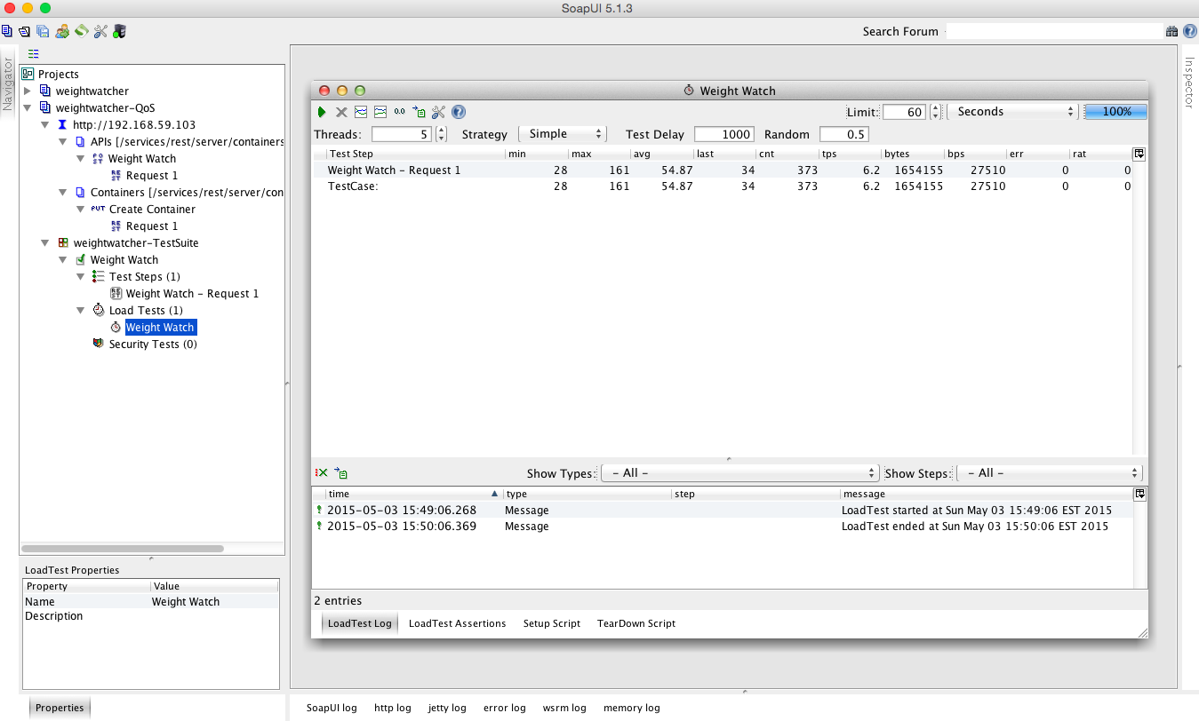

# Containers

## Container Deployment

Once you have completed the traditional installation described earlier you can then deploy the application as a docker image. Mac OS/X users may want to install boot2docker first. The steps are:

1. Stop the the jboss-eap-6.4 you started earlier
2. Zip the jboss-eap-6.4 installation located under \target you built earlier
3. Move the zip file to the \installs directory
4. Run the docker build script
5. Run the docker container
6. Locate the IP address used by this docker container
7. Make the necessary configuration changes using workbench and SoapUI
8. Bake the changes into the docker image
9. Restart the container

|  |
| --- |
| $ cd <path-to-project>  $ cd target  # Stop the running jboss server  $ zip -r jboss-eap-6.4.zip jboss-eap-6.4/  $ mv jboss-eap-6.4.zip ../installs/  $ cd ../  $ docker build -t spicozzi/weightwatcher .  # For Mac OS/X find IP address using  $ boot2docker ip  $ docker run -it -p 8080:8080 -p 9990:9990 spicozzi/weightwatcher |

Now repeat the configuration steps as described in section 4.; with the variation that you may need to delete the existing Decision Server before registering a new instance. Now that we have made these changes to the container, let's bake them into the image using a docker commit so we don't have to repeat these steps again. From a new terminal window:

$ cd <path-to-project>

$ docker ps

# Take note of the CONTAINER ID as <ID>

$ docker commit <ID> spicozzi/weightwatcher

# Stop the previous running container using Ctrl-C

$ docker run -it -p 8080:8080 -p 9990:9990 spicozzi/weightwatcher

You are then ready to explore the demo as described in section 5. The only thing you will need to do is restart the Container as described in section 5.1.